Calculation of internal forces in statically determinate simply supported beam
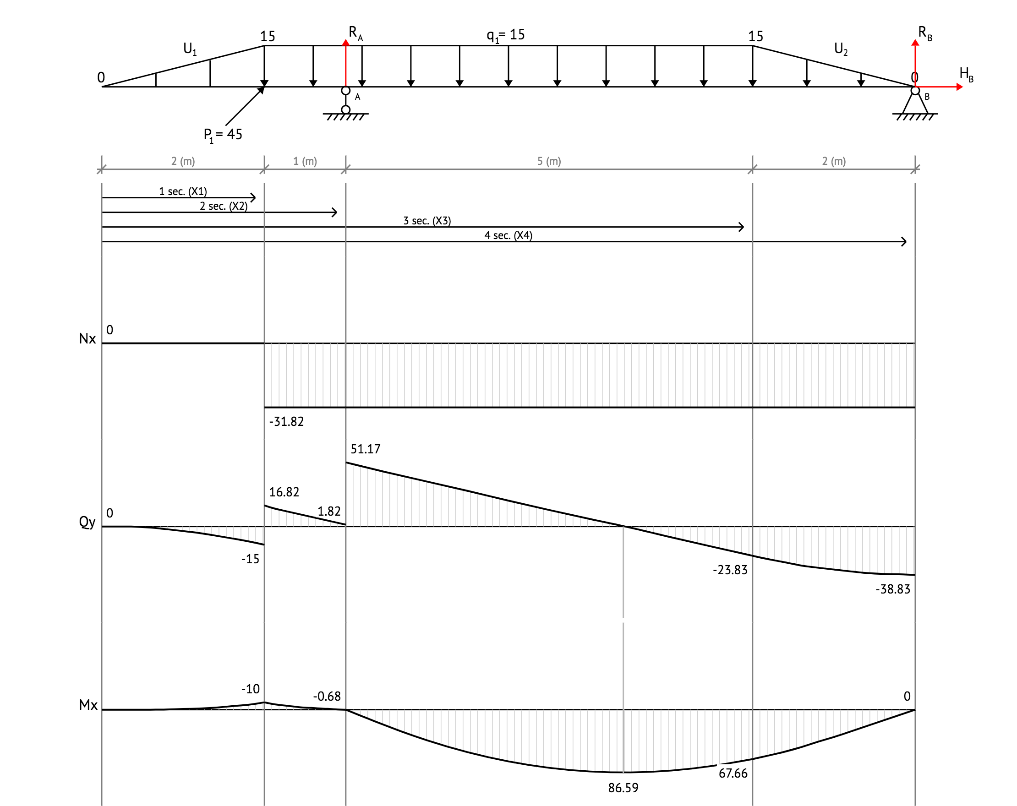
Fig.1 — Scheme of the beam

Calculate the reactions at the supports of a beam
1) A beam is in equilibrium when it is stationary relative to an inertial reference frame. The following conditions are satisfied when a beam, acted upon by a system of forces and moments, is in equilibrium.

The sum of the moments about the roller support at the point A:

The sum of the moments about the pin support at the point B:

2) Calculate reaction of pin support at the point B:

since the reaction of the support is negative, on the scheme we point it in the opposite direction.
3) Calculate reaction of roller support at the point A:

since the reaction of the support is negative, on the scheme we point it in the opposite direction.
4) Solve this system of equations:

5) The sum of the forces about the Oy axis is zero:

Draw diagrams for the beam
1) Consider first span of the beam 0 ≤ x₁ < 2
Determine the equations for the axial force (N):

The values of N at the edges of the span:

Determine the equations for the shear force (Q):

The values of Q at the edges of the span:

Determine the equations for the bending moment (M):

The values of M at the edges of the span:

2) Consider second span of the beam 2 ≤ x₂ < 3
Determine the equations for the axial force (N):

The values of N at the edges of the span:

Determine the equations for the shear force (Q):

The values of Q at the edges of the span:

Determine the equations for the bending moment (M):

The values of M at the edges of the span:

3) Consider third span of the beam 3 ≤ x₃ < 8
Determine the equations for the axial force (N):

The values of N at the edges of the span:

Determine the equations for the shear force (Q):

The values of Q at the edges of the span:

The value of Q on this span that crosses the horizontal axis. Intersection point: x = 3.41.
Determine the equations for the bending moment (M):

The values of M at the edges of the span:

Local extremum at the point x = 3.41:

4) Consider fourth span of the beam 8 ≤ x₄ < 10
Determine the equations for the axial force (N):

The values of N at the edges of the span:

Determine the equations for the shear force (Q):

The values of Q at the edges of the span:

Determine the equations for the bending moment (M):

The values of M at the edges of the span:

Selection of cross section
From the diagram of bending moments we determine that M_{max} = 86.59 (kN × m). Convert measurement units of the maximum bending moment with the SI system: M_{max} = 86.59 (kN × m) = 86590 (N × m).
From the shear diagram forces we determine that Q_{max} = 51.17 (kN). Convert measurement units of the maximum shear force with the SI system: Q_{max} = 51.17 (kN) = 51170 (N).
The condition for strength at bending stresses is:

where: М_{max} - maximum value of bending moment;
W_{x} - section modulus about a neutral axis Ox;
Calculate the value of the minimum required section modulus:

From the database select the nearest larger section number for which:

From AISC (American Institute of Steel Construction), select: Channel C12X25
The geometric characteristics of the selected section:
Section modulus with respect to the axis Ox: W_{x} = 24 (in³)
Section height: h = 12 (in)
Section width: b = 3.05 (in)
Wall thickness: t_{s} = 0.39 (in)
The average thickness of the shelves: t_{f} = 0.5 (in)
The static moment (first moment of area) relative to the axis Ox: S_{x} = 14.6 (in³)
The axial moment of inertia about the axis Ox: I_{x} = 144 (in⁴)

1) Calculate the bending stress of the beam with selected section (Channel C12X25):

2) Calculate the torsional stress of the beam with selected section (Channel C12X25):

where:
- the maximum value of the shear force;
- statical moment (first moment of area) of the cut-off part of the cross section relative to the neutral axis Ox;
- the width of the cross section of the beam at the point level;
- the moment of inertia of the section relative to the neutral axis Ox;

3) According to the theory of maximum tangential stress (third strength theory), calculate the equivalent stresses at the considered points of the selected cross section, according to the formula:

where y - distance from the center of gravity of the cross section to a selected point;
The torsional stress at the i-th point are calculated by the formula:

где
- the static moment (first moment of area) of the cut-off part of the section above the selected point, relative to the X axis;
- coordinate of the center of gravity of the cut off part of the section, relative to the X axis;
Choose to check 4 points in cross section:
1 point - with the coordinate y₁ = h/2, static moment (first moment of area) S_{x}(y = h/2) = 0;
2 point - with the coordinate у₂ = h/2 – t;
3 point - with the coordinate у₃ = h/2 – t; Static moment is the same as for the second point;
4 point - in the center of the section, with the coordinate у₄ = 0;
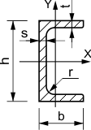

For point 1,
:

First moment of cut area
since

For point 2,
:

For point 3,
:

For point 4,
:

First moment of area
equal to the static moment (first moment of area) of half-section

Calculate maximum tangential stress in selected points of cross section:

Strength checks completed successfully. The section is chosen correctly. Finally from AISC (American Institute of Steel Construction) choose: Channel C12X25
Parameters of the selected section:
Section modulus with respect to the axis Ox: W_{x} = 24 (in³)
Section height: h = 12 (in)
Section width: b = 3.05 (in)
Wall thickness: t_{s} = 0.39 (in)
The average thickness of the shelves: t_{f} = 0.5 (in)
The static moment (first moment of area) relative to the axis Ox: S_{x} = 14.6 (in³)
The axial moment of inertia about the axis Ox: I_{x} = 144 (in⁴)

